**SQL Code For Various Analysis**

#### **1. Top 30 Bollers**

select Player_Name, p.player_id, sum(Bowling_skill) as Skills from player p

join ball_by_ball b on b.Bowler = p.Player_Id

where b.Bowler = p.Player_Id

group by Player_Name, p.player_id

order by Skills desc

limit 30;

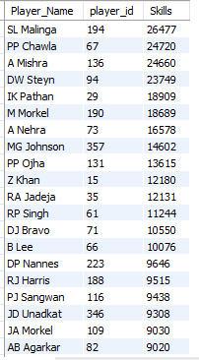

#### **2. Top 35 Batsman**

select * from (

select Player_Name,

sum(Runs_Scored) as total

from player p

join player_match pm

on p.Player_Id = pm.Player_Id

join batsman_scored bs

on pm.Match_Id = bs.Match_Id

group by Player_Name ) as A

order by total desc

limit 35;

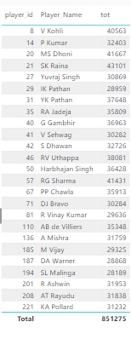

#### **3. Top 5 Wicket-keepers**

select Player_Name, count(Role_Desc) AS Skill_Points from player p

join player_match pm on p.Player_Id = pm.Player_Id

join role r on r.role_id = pm.role_id

where r.role_id = 2 or r.role_id = 4

group by Player_Name

order by Skill_Points desc limit 5;

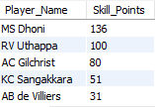

#### **4. Most Sixes by players**

select * from

(select pm.match_id, player_name, count(runs_scored) as total_sixes

from batsman_scored bs

join player_match pm

on pm.match_id = bs.match_id

join player p

on p.Player_id=pm.Player_id

where Runs_scored = 6

group by pm.match_id, player_name ) as A

order by total_sixes desc;

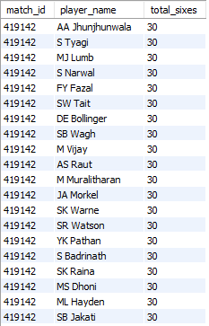

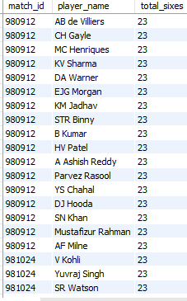

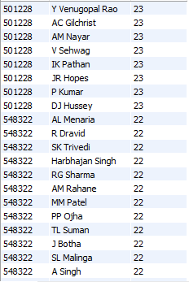

#### **5. Most Fours by players**

select * from (select pm.match_id, player_name, count(runs_scored) as total_four

from batsman_scored bs

join player_match pm

on pm.match_id = bs.match_id

join player p on p.Player_id=pm.Player_id

where Runs_scored = 4

group by pm.match_id, player_name ) as A

order by total_four desc;

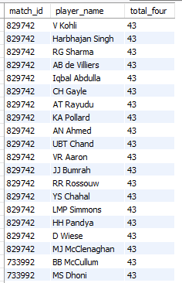

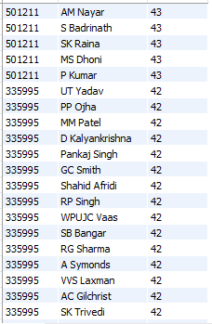

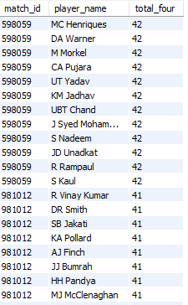

#### **6. Win Margin:**

**SQL query :**

SELECT

Match_ID,

Match_Winner,

CASE

WHEN W.Win_Type = 'runs' THEN M.Win_Margin

WHEN W.Win_Type = 'wickets' THEN M.Win_Margin

ELSE NULL

END AS WinMargin

FROM

win_by W

JOIN match_ M

ON W.Win_Id = M.Win_Type

WHERE

W.Win_Type IN ('Runs', 'Wickets');

* Query Gives : Win Margin

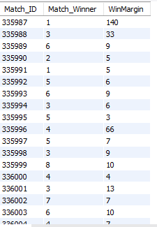

#### **7. Average Run Rate by Season:**

**SQL query :**

SELECT

Season_Year ,

SUM(Runs_Scored) / SUM(Over_Id) AS AverageRunRate

FROM

batsman_scored B

JOIN match_ M

ON B.Match_Id = M.Match_Id

JOIN season S

ON M.Season_Id = S.Season_Id

GROUP BY

Season_Year

ORDER BY

Season_Year;

* Query Gives : Average Run Rate by Season Year

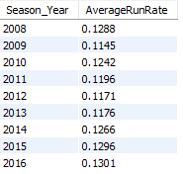

#### **8. Win type** **:**

**SQL query :**

SELECT

Win_Type,

COUNT(*) AS DismissalCount

FROM

win_by

GROUP BY

Win_Type

ORDER BY

DismissalCount DESC;

* Query Gives :Win Types

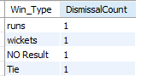

#### **9. Player Consistency:**

**SQL query :**

SELECT

Player_Name,

Season_Year,

AVG(Runs_Scored) AS AverageRuns

FROM

player P

JOIN player_match PM

ON P.Player_Id = PM.Player_Id

JOIN match_ M

ON PM.Match_Id = M.Match_Id

JOIN season S

ON S.Season_Id = M.Season_Id

JOIN batsman_scored BS

ON BS.Match_Id = M.Match_Id

GROUP BY

Player_Name,

Season_Year

ORDER BY

Player_Name,

Season_Year;

* Query Gives :Player Consistency

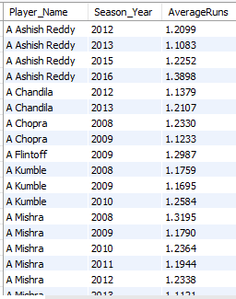

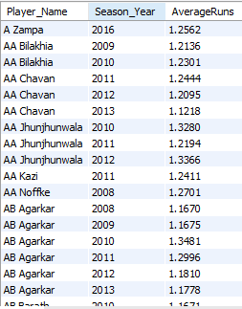

#### **10. Performance by Venue:**

**SQL query :**

SELECT

Venue_Name,

AVG(Runs_Scored) AS AverageRuns

FROM

venue V

JOIN match_ M

ON M.Venue_Id = V.Venue_Id

JOIN batsman_scored B

ON M.Match_Id = B.Match_Id

GROUP BY

Venue_Name

ORDER BY

AverageRuns DESC;

* Query Gives :Performance by Venue

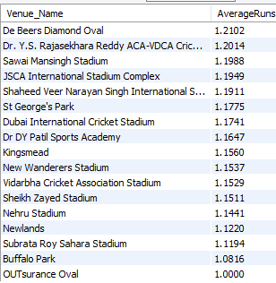

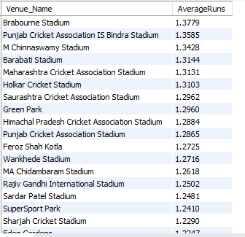

#### **11. Over Analysis:**

**SQL query :**

SELECT

W.Over_Id,

COUNT(DISTINCT M.Match_Id) AS TotalOvers,

SUM(Runs_Scored) AS TotalRuns,

AVG(Runs_Scored) AS AverageRunsPerOver

FROM

wicket_taken W

JOIN match_ M

ON W.Match_Id = M.Match_Id

JOIN batsman_scored BS

ON BS.Match_Id =M.Match_Id

GROUP BY

W.Over_Id

ORDER BY

W.Over_Id;

* Query Gives : Over Analysis

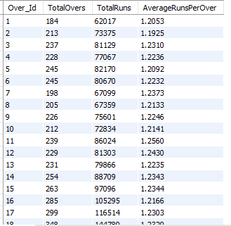

#### **12. Bowler Types:**

**SQL query :**

SELECT

BS.Bowling_skill , SUM(ER.Extra_Runs) AS EXTRARUN ,

SUM(Runs_Scored)

FROM

bowling_style BS

JOIN extra_runs ER

ON BS.Bowling_Id = ER.Ball_Id

JOIN batsman_scored BS

ON BS.Ball_Id = ER.Ball_Id

;

* Query Gives : Bowler Types

#### **13. Performance in Final Matches:**

**SQL query :**

SELECT

Match_Id , Innings_No , SUM(Runs_Scored) AS TOTAL_RUN

FROM batsman_scored

GROUP BY Match_Id , Innings_No

ORDER BY TOTAL_RUN DESC;

* Query Gives : Performance in Finals

#### **14. Head-to-Head Records:**

**SQL query :**

SELECT

Team_1 AS Team,

Team_2 AS Opponent,

COUNT(*) AS MatchesPlayed,

SUM(CASE WHEN Match_Winner = Team_1 THEN 1 ELSE 0 END) AS WinsForTeam,

SUM(CASE WHEN Match_Winner = Team_2 THEN 1 ELSE 0 END) AS WinsForOpponent

FROM

match_

GROUP BY

Team_1, Team_2

UNION ALL

SELECT

Team_2 AS Team,

Team_1 AS Opponent,

COUNT(*) AS MatchesPlayed,

SUM(CASE WHEN Match_Winner = Team_2 THEN 1 ELSE 0 END) AS WinsForTeam,

SUM(CASE WHEN Match_Winner = Team_1 THEN 1 ELSE 0 END) AS WinsForOpponent

FROM

match_

GROUP BY

Team_2, Team_1;

* Query Gives : Head-to-Head Records

#### **15. Player Nationalities:**

**SQL query :**

SELECT

Country_Name AS COUNTRY_CODE,

COUNT(Player_Id) AS NumberOfPlayers

FROM

player P

GROUP BY

Country_Name

ORDER BY

NumberOfPlayers DESC;

* Query Gives : Player Nationalities

#### **16. Top Scores by Batting_hand:**

**SQL query :**

SELECT

Batting_hand,

Player_Name,

Runs_Scored,

Match_Id

FROM

(SELECT

P.Batting_hand,

P.Player_Name,

BS.Runs_Scored,

M.Match_Id,

ROW_NUMBER() OVER (PARTITION BY P.Batting_hand ORDER BY BS.Runs_Scored DESC) AS rank_

FROM

player P

JOIN player_match PM

ON P.Player_Id = PM.Player_Id

JOIN match_ M

ON M.Match_Id = PM.Match_Id

JOIN batsman_scored BS

ON M.Match_Id = BS.Match_Id

) ranked

WHERE

rank_ = 1

ORDER BY Batting_hand;

Query Gives : Top Scores by Batting_hand

#### **17. Player Contributions:**

**SQL query :**

SELECT

P.Player_Name,

T.Team_Name,

SUM(BS.Runs_Scored) AS TotalRuns,

SUM(Player_Out) AS TotalWickets

FROM

player P

JOIN player_match PM

ON P.Player_Id = PM.Player_Id

JOIN team T

ON T.Team_Id = PM.Team_Id

JOIN batsman_scored BS

ON PM.Match_Id = BS.Match_Id

JOIN wicket_taken W

ON W.Match_Id = PM.Match_Id

GROUP BY

P.Player_Name,

T.Team_Name

ORDER BY

TotalRuns DESC;

* Query Gives : Player Contributions

#### **18. Milestone Matches:**

**SQL query :**

WITH RankedMatches AS (

SELECT

P.Player_Id,

Player_Name,

M.Match_Id,

Match_Date,

ROW_NUMBER() OVER (PARTITION BY Player_Id ORDER BY Match_Date) AS MatchNumber

FROM

player P

JOIN player_match PM

ON P.Player_Id = PM.Player_Id

JOIN match_ M

ON PM.Match_Id = M.Match_Id

)

SELECT

Player_Id,

Player_Name,

Match_Id,

Match_Date,

MatchNumber

FROM

RankedMatches

WHERE

MatchNumber IN (50, 100)

ORDER BY

Player_Name, MatchNumber;

* Query Gives : Milestone Matches

#### **19. Win by Toss Decision:**

**SQL query :**

SELECT

TD.Toss_Name,

COUNT(*) AS TotalMatches,

SUM(CASE WHEN M.Match_Winner = Toss_Winner THEN 1 ELSE 0 END) AS WinsAfterWinningToss,

SUM(CASE WHEN M.Match_Winner != Toss_Winner THEN 1 ELSE 0 END) AS LossesAfterWinningToss,

SUM(CASE WHEN M.Match_Winner = Toss_Winner THEN 1 ELSE 0 END) * 100.0 / COUNT(*) AS WinPercentage

FROM

toss_decision TD

JOIN match_ M

ON TD.Toss_Id = M.Toss_Decide

GROUP BY

TD.Toss_Name

ORDER BY

TD.Toss_Name;

* Query Gives : Win by Toss Decision

#### **20. Match Locations:**

**SQL query :**

SELECT

Venue_Name,

City_Name,

COUNT(*) AS TotalMatches,

COUNT(DISTINCT Season_Year) AS SeasonsHosted,

COUNT(DISTINCT Team_1) + COUNT(DISTINCT Team_2) AS TeamsPlayed,

COUNT(DISTINCT Match_Winner) AS UniqueWinners

FROM

venue V

JOIN city C

ON V.City_Id = C.City_Id

JOIN match_ M

ON M.Venue_Id = V.Venue_Id

JOIN season S

ON M.Season_Id = S.Season_Id

GROUP BY

Venue_Name,

City_Name

ORDER BY

TotalMatches DESC;

* Query Gives : Match Locations

#### **21. Overseas Player Performances:**

**SQL query :**

SELECT

P.Player_Name,

C.Country_Name,

SUM(Runs_Scored) AS TotalRuns,

SUM(Player_Out) AS TotalWickets,

COUNT(M.Match_Id) AS MatchesPlayed

FROM

player P

JOIN country C

ON P.Country_Name = C.Country_Id

JOIN player_match PM

ON P.Player_Id = PM.Player_Id

JOIN match_ M

ON M.Match_Id = PM.Match_Id

JOIN batsman_scored BS

ON M.Match_Id = BS.Match_Id

JOIN wicket_taken WT

ON M.Match_Id = WT.Match_Id

WHERE

C.Country_Name != 'India'

GROUP BY

P.Player_Name,

C.Country_Name

ORDER BY

TotalRuns DESC, TotalWickets DESC;

* Query Gives : Overseas Player Performances

#### **22. Run Rate in Powerplay:**

**SQL query :**

SELECT

M.Match_Id,

WT.Innings_No,

SUM(Runs_Scored) AS TotalRuns,

COUNT(WT.Ball_Id) AS TotalBalls,

ROUND(SUM(Runs_Scored) * 6.0 / COUNT(WT.Ball_Id), 2) AS PowerplayRunRate

FROM

match_ M

JOIN wicket_taken WT

ON M.Match_Id = WT.Match_Id

JOIN batsman_scored BS

ON M.Match_Id = BS.Match_Id

WHERE

WT.Over_Id BETWEEN 1 AND 6

GROUP BY

M.Match_Id,

Innings_No

ORDER BY

M.Match_Id,

Innings_No;

* Query Gives : Run Rate in Powerplay

#### **23. Death Over Analysis:**

**SQL query :**

SELECT

M.Match_Id,

WT.Innings_No,

SUM(Runs_Scored) AS TotalRuns,

COUNT(WT.Ball_Id) AS TotalBalls,

ROUND(SUM(Runs_Scored) * 6.0 / COUNT(Runs_Scored), 2) AS DeathOverRunRate

FROM

match_ M

JOIN wicket_taken WT

ON M.Match_Id = WT.Match_Id

JOIN batsman_scored BS

ON M.Match_Id = BS.Match_Id

WHERE

WT.Over_Id BETWEEN 17 AND 20

GROUP BY

M.Match_Id,

WT.Innings_No

ORDER BY

M.Match_Id,

WT.Innings_No;

* Query Gives : Death Over Analysis

#### **24. Player Transfers:**

**SQL query :**

SELECT

Player_Name,

Season_Year,

Team_1 AS From_team,

Team_2 AS To_team

FROM

player P

JOIN

player_match PM ON P.Player_Id = PM.Player_Id

JOIN match_ M

ON PM.Match_Id = M.Match_Id

JOIN season S

ON S.Season_Id = M.Season_Id

ORDER BY

Season_Year, Player_Name;

* Query Gives :Player Transfers